Risk Register Form

Screenshots from “Risk Register Form.xslx”

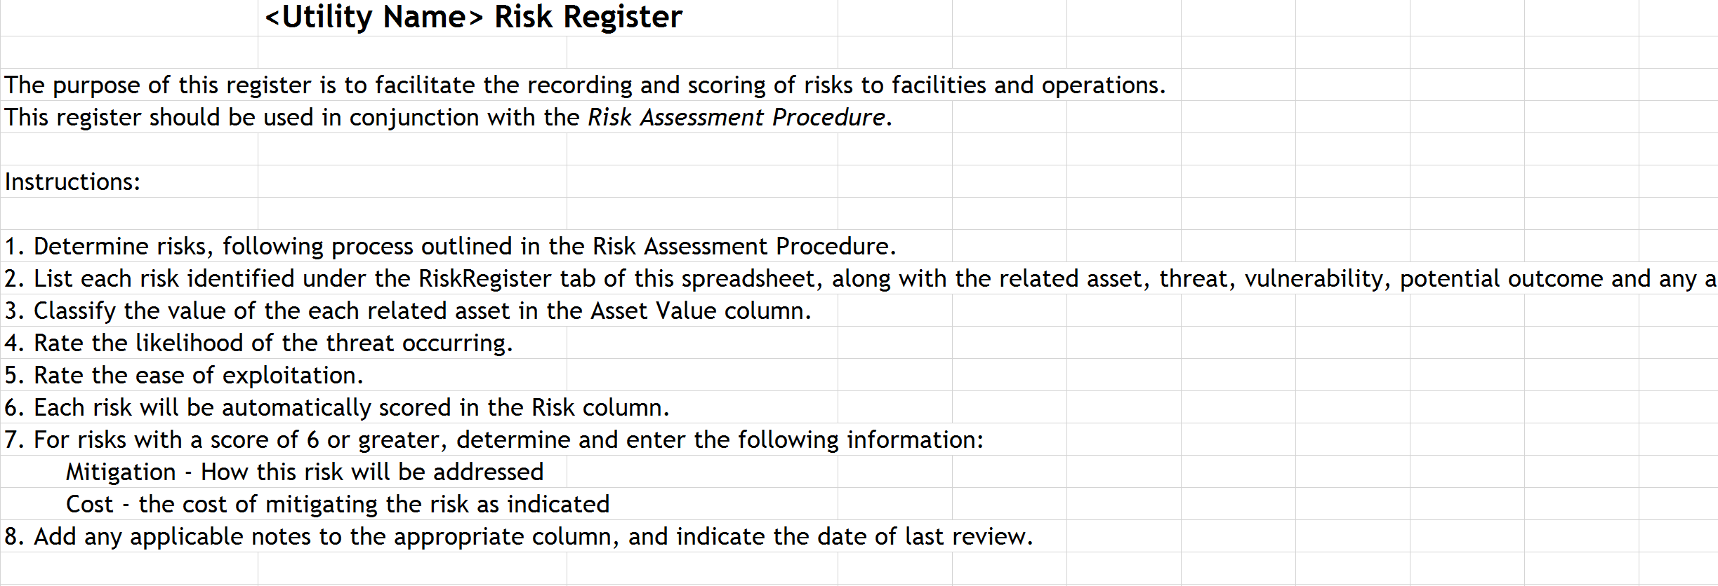

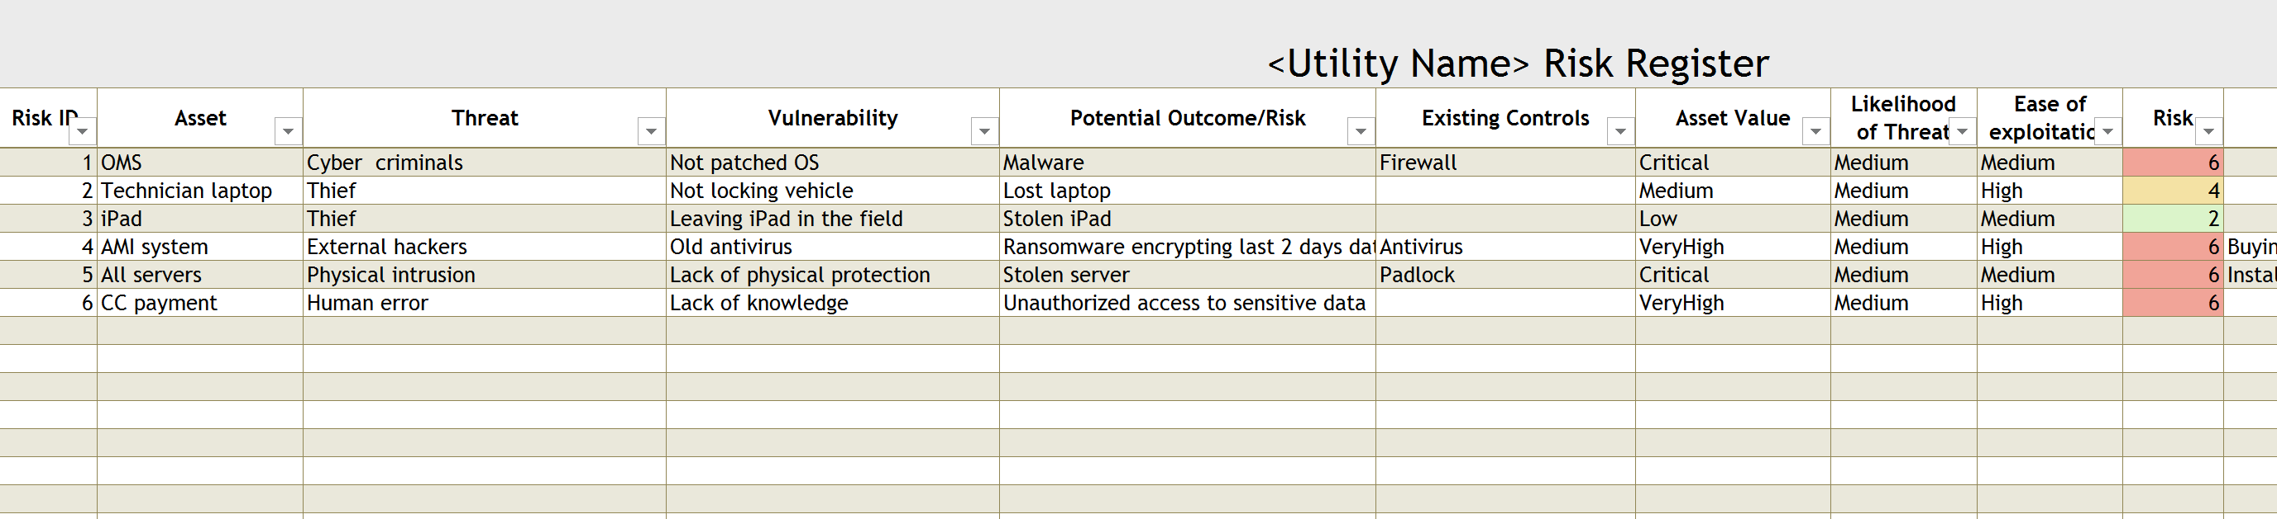

Asset Value – Low to Critical with numeric value from 0 to 4

Likelihood of Threat – Low to High with numeric value from 0 to 2

Ease of exploitation – Low to High with numeric value from 0 to 2

Risk is calculated as a sum of Asset Value, Likelihood of Threat and Ease of exploitation

